Ideation Phase

Define the Problem Statements

|  |  |
| --- | --- |
| Date | 27 June 2025 |
| Team ID | **LTVIP2025TMID24658** |
| Project Name | **DocSpot — Seamless Appointment Booking for Health** |
| Maximum Marks | 2 Marks |

**Customer Problem Statement Template:**

Create a problem statement to understand your customer's point of view. The Customer Problem Statement template helps you focus on what matters to create experiences people will love.

A well-articulated customer problem statement allows you and your team to find the ideal solution for the challenges your customers face. Throughout the process, you’ll also be able to empathize with your customers, which helps you better understand how they perceive your product or service.

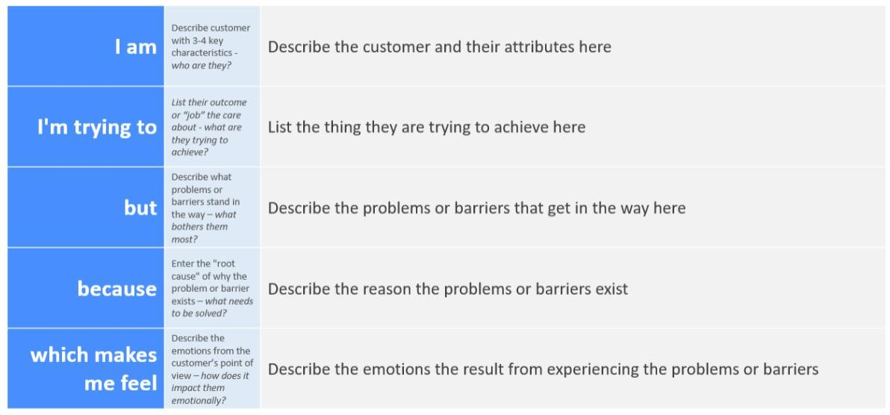

Reference: <https://miro.com/templates/customer-problem-statement/>

**Example:**

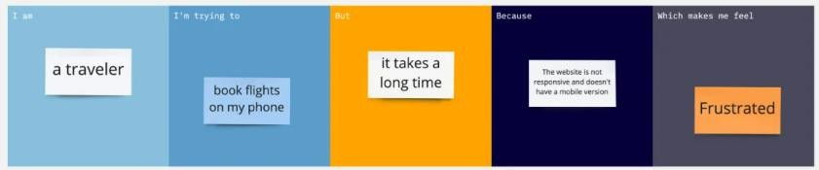

|  |  |  |  |  |  |
| --- | --- | --- | --- | --- | --- |
| **Problem**  **Statement (PS)** | **I am**  **(Customer)** | **I’m trying to** | **But** | **Because** | **Which makes me feel** |
| PS-1 | a college student living in a | order groceries, stationery, | I have to switch between | no single platform provides all | irritated and time- constrained |

|  |  |  |  |  |  |
| --- | --- | --- | --- | --- | --- |
|  | hostel | and daily essentials quickly from a single app | different apps and websites for each  category | types of products I need at affordable  prices |  |
| PS-2 | working professional with a tight schedule | buy household items and electronics online during short breaks | I waste time comparing prices and delivery times on multiple  platforms | there’s no unified solution that offers product comparison and smart suggestions | overwhelmed and indecisive |